**OUTPUT:**

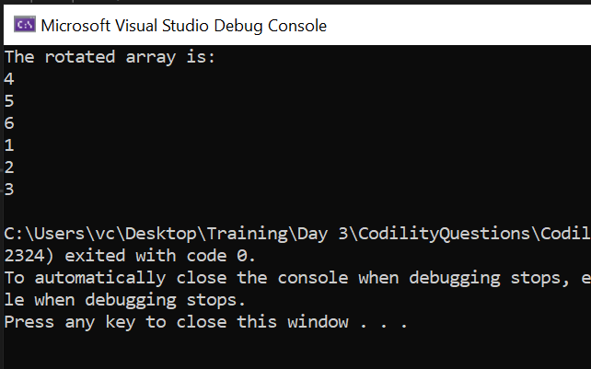

**CODE:**

using System;

using System.Collections.Generic;

using System.Linq;

using System.Text;

using System.Threading.Tasks;

namespace CodilityQuestions

{

internal class Program1

{

static void Main(string[] args)

{

int[] arr = [1,2,3,4,5,6];

int d = 3;

int[] arr1 = new int[arr.Length];

int j = 0;

for (int i = d; i < arr.Length; i++)

{

arr1[j] = arr[i];

j++;

}

for(int i=0; i<d; i++)

{

arr1[j] = arr[i];

j++;

}

Console.WriteLine("The rotated array is:");

for (int i = 0; i < arr1.Length; i++)

{

Console.WriteLine(arr1[i]);

}

}

}

}